Python Script for Viewing Logfile Data

## Setup

Download Anaconda.

Notepad ++ is also helpful, or another good notepad program.

## Running the Script

Put your logfile in the CSV folder of python logger desktop folder

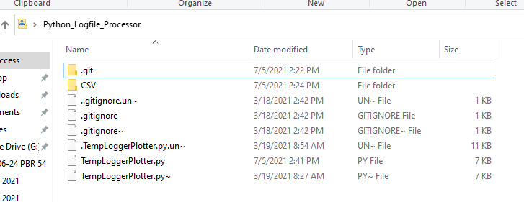

Open the TempLoggerPlotter.py file in a text editor (e.g. notepad ++) and change the logfile to be correct here

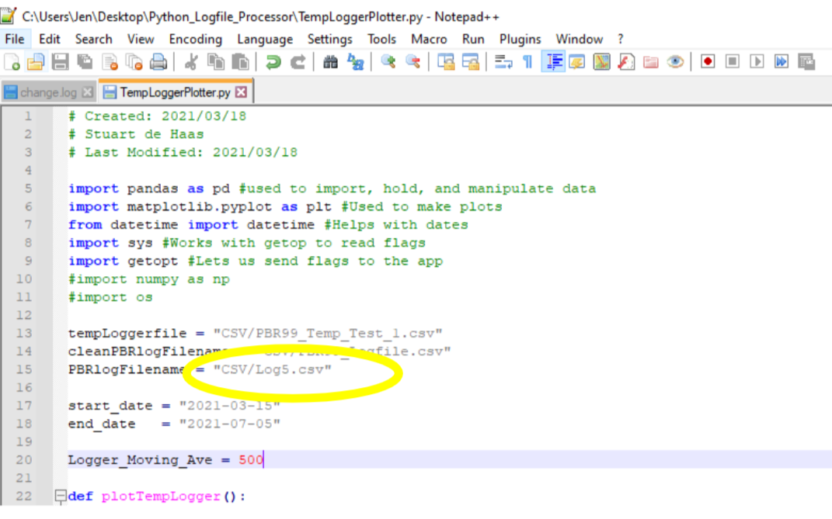

If there is a culture name this flag will have to be 2, otherwise leave as 1

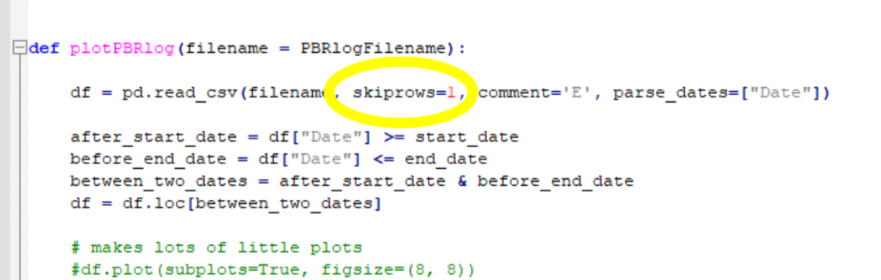

Make sure to change the start and end dates as required.

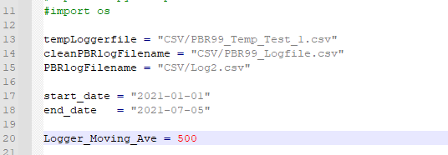

Open powershell

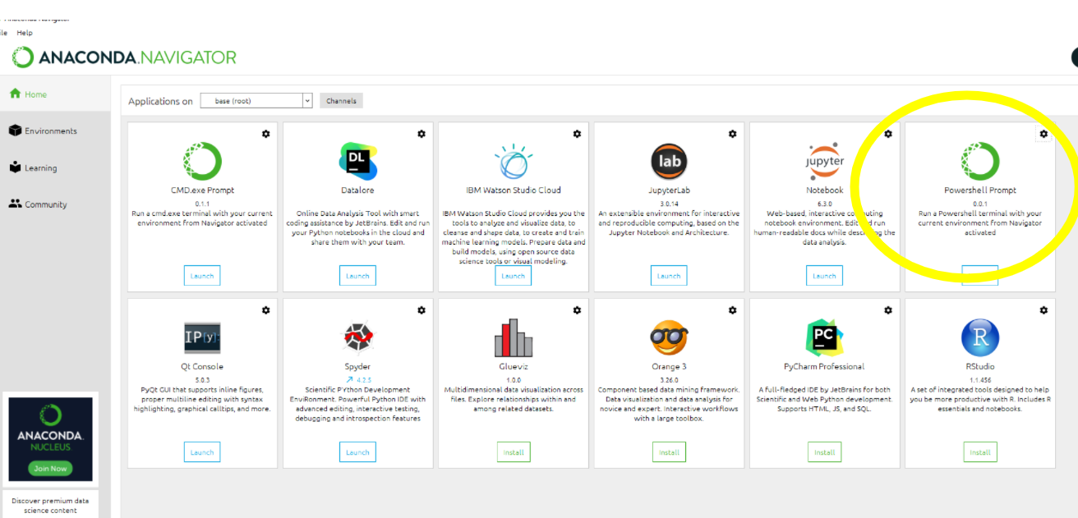

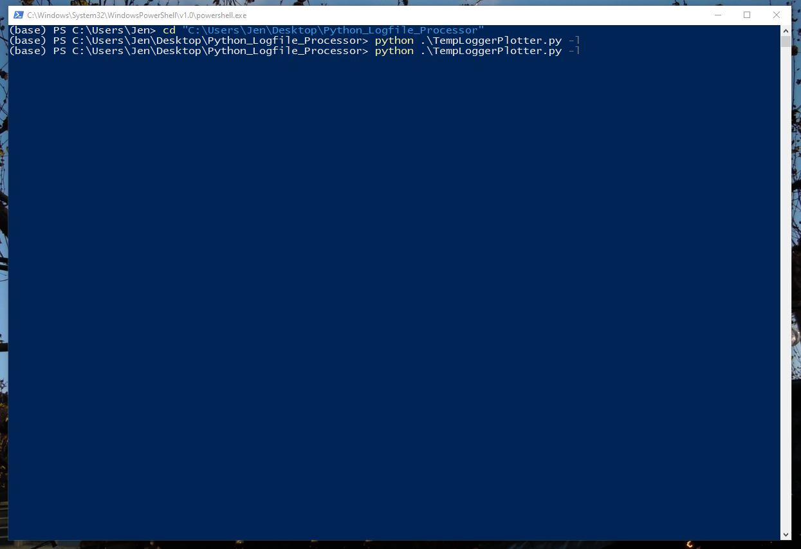

Run as above in powershell. The -l at the end runs logfile viewer mode whereas -t runs temp plotter mode (with external ambient temperature file), -s plots sensor box data and -r is for high resolution (raw) logfiles

Get graph

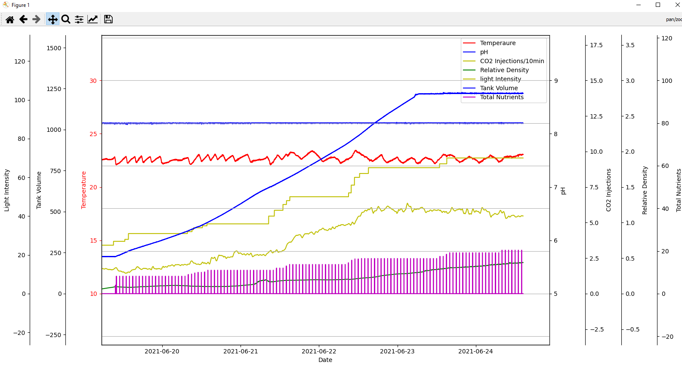

## Navigating and Customizing the Graph

Graph scaling can be set here

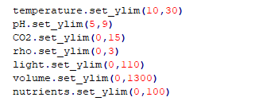

To hide certain traces you can add an alpha setting to each trace to be hidden

E.g. here hiding everything except pH and CO2

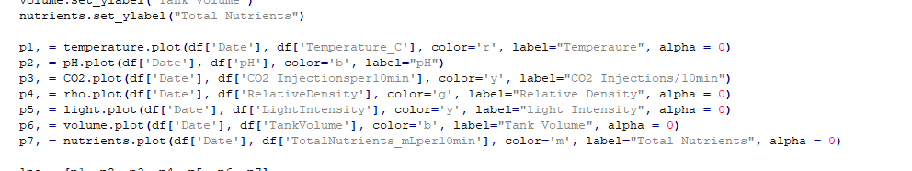

## Troubleshooting

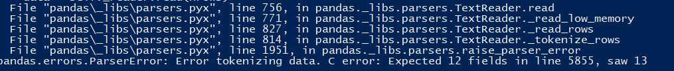

If you get this error, add an extra header column to logfile (e.g. Misc)

If you have the file input correctly, you may have to change whether the file is doing sensor box or raw mode:

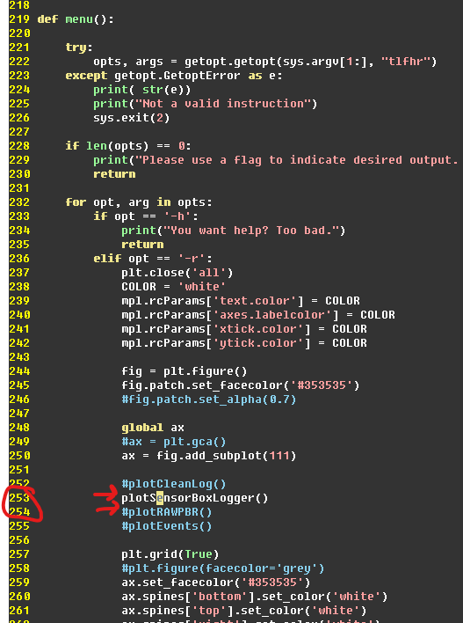

Comment out whichever one you aren’t using.